**Task 1.10: Project Reflections**

GameCo’s Expectation: GameCo’s executive board currently expects that sales for the various geographic regions have stayed the same historically.

Our target audience is GameCo’s executive board is made up of multiple stakeholders, the Vice President of Marketing, Chief Financial Officer, and Senior Vice President of Sales. Each of these stakeholders will want to be able to answer different questions based on their needs. The specific questions they are interested in learning about I chose to explore are:

● Are certain types of games more popular than others?

● What other publishers will likely be the main competitors in certain markets?

Step 1:

Based on the executive board’s expectations stated above I first wanted to analyze historical sales data from 2006-2016. I chose this timeframe because I felt data older than 2016 would not accurately reflect current sales trends. I also chose to only include the three biggest regional markets so this analysis could have the strongest impact for the stakeholders.

Line chart describing trends in regional sales from 2006-2016.

In the above visualization we see that the total number of units sold has declined over the past 10 years in all regions. This contradicts the original expectations of the stakeholders. Next, I wanted to visualize the market share for each of the regional markets.

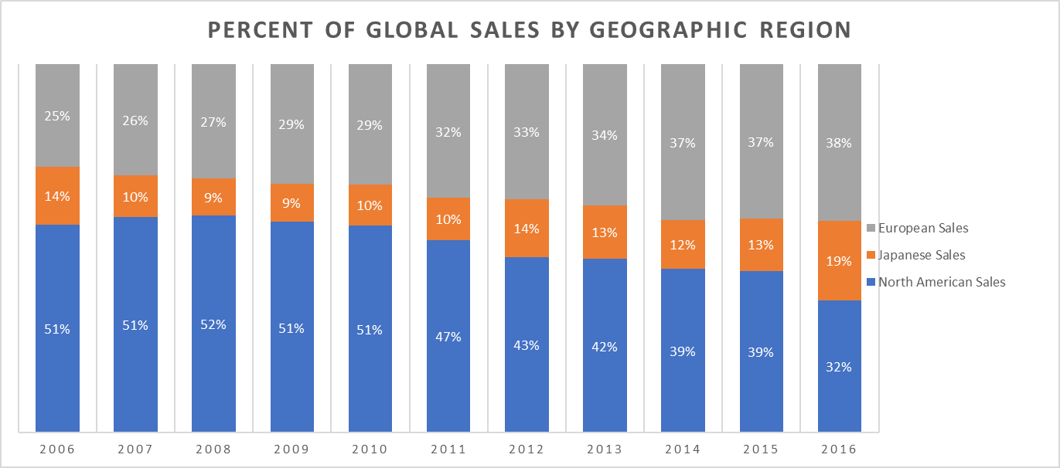

100% Stacked Column chart describing percent of global sales for each geographic region from 2006-2016.

The above visualization shows us some interesting information about each region and how they are trending. We first notice that from 2006-2010 North America held almost 50% of the market share of units sold, followed by Europe, and then Japan. Then something interesting happens starting in 2011. The European market share gradually increases from 2011-2016 as the North American market share steadily declines. Once again, the data suggests that the executive boards expectations were inaccurate and further analysis of the data is required to gain insights into “Why?” this is happening.

Step 4:

I chose to use clustered column charts to show visualize total units sold in millions for genre and platform data for 2016 to show stakeholders what is currently popular in each region. I also chose to use clustered column charts to display the top 10 publishers based on average units sold in million for each region and globally from 2012-2016. I chose clustered column charts because I like how they clearly display the data I summarized in my pivot tables. Choosing how to allocate money for marketing in different regions seems like it can be complicated, so I wanted to make the visualizations clearly tell a story about what is happening in each region.

Clustered column chart describing average North American sales for the top 10 publishers.

My visualizations from step 1 suggested to me that there were differences in more than just sales amongst the different regions. So based on questions presented in the project brief I took a different route in my analysis. I wanted to include analysis and visualizations that all the stakeholders could find useful.